**CAB302 Market Research**

**Competitors (Desktop Word Games)**

Classic Competitors:

Scrabble (Digital Editions)

* These are usually direct digital copies of the board game.
* They use the same beige and wooden tile look, with the traditional red, blue, and green bonus squares.
* Functionality is simple: place tiles, score points, maybe play against an AI.
* The problem is that the UI often feels stiff and dated. Animations are minimal, and the game doesn’t feel lively.

**Words With Friends (Desktop/Web version)**

* Originally a mobile game, but you can play it on computer through browsers.
* It’s brighter and more colourful, with a friendlier feel than Scrabble.
* Features include daily bonuses, leaderboards, and social elements like chatting.
* However, the desktop experience isn’t great, it’s designed for quick taps on a phone, not an immersive PC game.

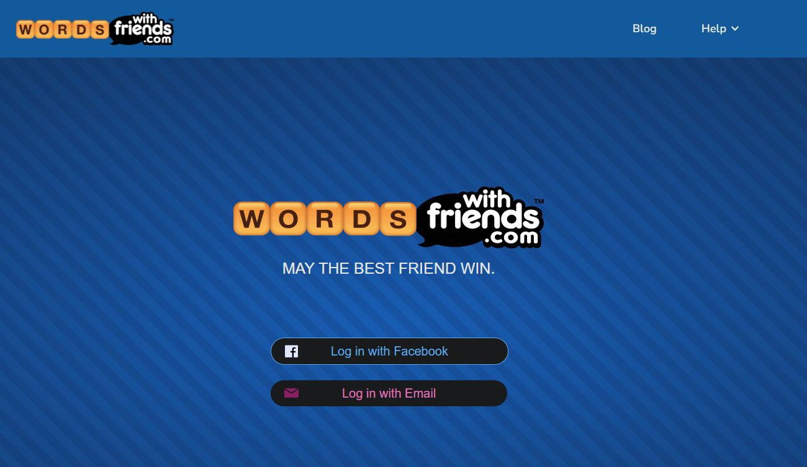

**Standard Word Search Software**

* There are plenty of small programs or websites where you can play word search on computer.
* The design is usually plain: a white grid with black letters, highlight words in yellow when found.
* These games do the job, but they don’t have much personality.

**Modern / Indie Competitors**

* Balatro (2024 indie hit, PC)
* Not a word game, but a great example of how a “quiet” genre (card games) can be made exciting.
* Uses dark backgrounds, glowing neon effects, and bold animations.
* Players keep coming back because of roguelike systems (random runs, modifiers, replayability).
* Our project can learn from this: even a simple concept like spelling words can feel fresh and cool with the right style and progression.

**Bookworm Adventures (PopCap, PC)**

* A more playful take where you spell words to attack monsters.
* Uses bright storybook visuals, light humour, and a sense of progression.
* Shows how adding small narrative or reward elements makes word games more engaging.

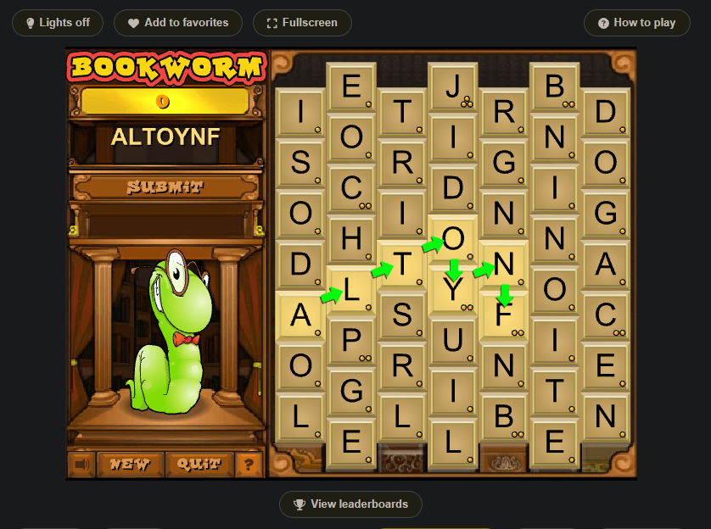

**Letter Quest / Typoman (PC)**

* Word mechanics are used for combat or exploration.
* These games prove that spelling isn’t just about points—it can be turned into challenges, battles, or puzzles.

**Visual and Design Trends Desktop Focus Only**

**Colors:**

* Traditional Scrabble: muted wood and pastel tones, serious and formal.
* Casual word games: bright and cheerful, with yellows, oranges, and blues.
* Indie/PC style (Balatro influence): dark backgrounds with neon highlights—purple, green, cyan, and gold—giving a bold arcade feel.

**For our game:**

Since we’re focusing on computer play, dark mode with glowing highlights will work best. It will reduce eye strain for long sessions but also look modern. We can make the tiles pop with glowing edges and give extra feedback (like flashing or pulsing) when a good word is played.

**Buttons and Interactions:**

* Old Scrabble programs: tiny rectangular buttons (“Play”, “Shuffle”, “Pass”), no animation.
* Modern word games: bigger rounded buttons, colourful icons, hover effects.
* PC indie games: tactile, arcade-like buttons that glow, shake, or bounce when clicked.

**For our game:**

We should make buttons large and satisfying, with hover glow effects. For example, “Shuffle Rack” could spin the tiles, or “Confirm Word” could pulse green when ready. Animations will make the game feel alive rather than flat.

**Features and Functionalities**

Based on what competitors offer, most desktop word games share a few core features:

* A letter rack or grid.
* A scoring system.
* A timer or turn limit.

**Where we can differentiate:**

* Multiple Modes
* Classic Scrabble-style word forming.
* Word Search mode with hidden words.
* Challenge mode (e.g., only words with “Q” allowed).
* Combo Scoring – bonus streaks for finding words quickly or making longer words.
* Visual Feedback – flying tiles, glowing scores, animations when bonuses activate.
* Daily Challenges – keeps people coming back.
* Leaderboards – offline for now, but could expand to online later.
* Unlockable Themes – players can earn skins (wooden Scrabble, neon arcade, retro pixel).

**Opportunities for Desktop**

Most word games today are designed for phones. On computer, players expect something a bit deeper, with more atmosphere. The biggest opportunity is to take the comfort and logic of word games and combine them with the energy of arcade-style PC indies.

**By building:**

* A desktop-first UI
* A strong visual identity (dark, neon, glowing effects),
* Fun progression like challenges and unlocks,
* …our game could stand out as a Scrabble/word search for the modern PC audience.